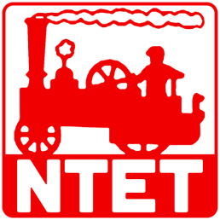 | National Traction Engine Trust  Preserving our Heritage with Steam on the Road
 | Bursary Application

Name:
Address:

Phone No:
Email:
SAC or NTET membership number:

Why are you applying?

How much are you applying for and what is the total project cost?

Are you applying for funding from other sources, and if so where?

Do you expect this will lead to future employment?

Are you currently in Higher Education?

Is this intended to help you expand your skills in your spare time activities?

References (if applicable)

You may be required to attend an interview. Please note: - maximum limit for application is £500. For courses starting in September please ensure your application arrives before 31st July.

Please include as much information as you can. Pictures and other supporting evidence are welcome.

Email this form to general.secretary@ntet.co.uk

